8.55: a) The average thrust is the impulse divided by the time, so the ratio of the average thrust to the maximum thrust is 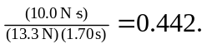 b) Using the average force in Eq. (8.38), 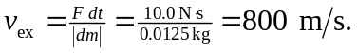 c) Using the result of part (b) in Eq. (8.40), .

